Comp 3350: Computer Organization & Assembly Language

HW # 5: Theme: Data Definitions, Addressing Modes, Arrays
All main questions carry equal weight.
(Credit awarded to only those answers for which work has been shown.)

- [Memory Map] Fill in the following memory diagram with the data provided below. Please assume that the data segment begins at 0x0038E000.

.data
Alpha DWORD 1A2B3C4Dh, 12AB34CCh
Beta BYTE 7Ch
Gamma DWORD 9ABCDEF0h
Delta BYTE 12h

Address | Variable | Data
0038E000 | ALPHA | 4Dh
0038E001 | ALPHA | 3Ch
0038E002 | ALPHA | 2Bh
0038E003 | ALPHA | 1Ah
0038E004 | ALPHA | CCh
0038E005 | ALPHA | 34h
0038E006 | ALPHA | ABh
0038E007 | ALPHA | 12h
0038E008 | BETA | 7Ch
0038E009 | GAMMA | F0h
0038E00A | GAMMA | DEh
0038E00B | GAMMA | BCh
0038E00C | GAMMA | 9Ah
0038E00D | Delta | 12h

- [Addressing Modes] Copy the following code into your assembly development environment and single-step through it. For each single step execution, submit the screenshot. For those instructions referencing memory, do the linear address computation (typewritten).

TITLE Addressing Modes (main.asm)
INCLUDE Irvine32.inc
.data
alpha DWORD 65219751h, 24875139h
beta DWORD 3B2C791Ah, 0A57716Dh
gamma DWORD 0C58Bh

.code
main PROC
mov eax, 1111h; Immediate
mov ecx, eax; Register to Register
mov edi, OFFSET beta; Immediate
mov [gamma], eax; Direct
mov esi, gamma; Direct
mov esi, 4; Immediate
mov eax, beta[esi]; Indirect-offset
mov ebx, OFFSET alpha; Immediate
mov eax, [ebx]; Indirect
mov eax, 4[ebx]; Indirect-displacement
mov eax, 4[ebx][esi]; Base-Indirect-displacement
exit
main ENDP
END main

STEP 1:
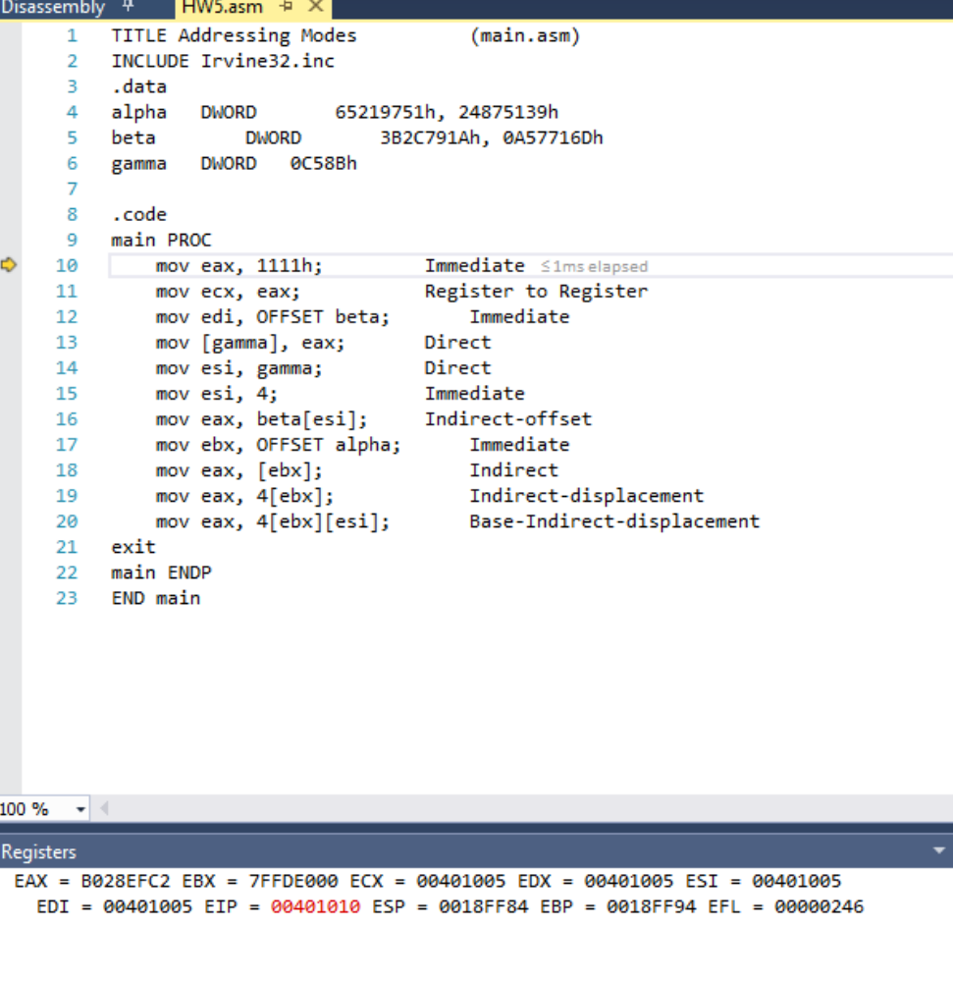

STEP 2:
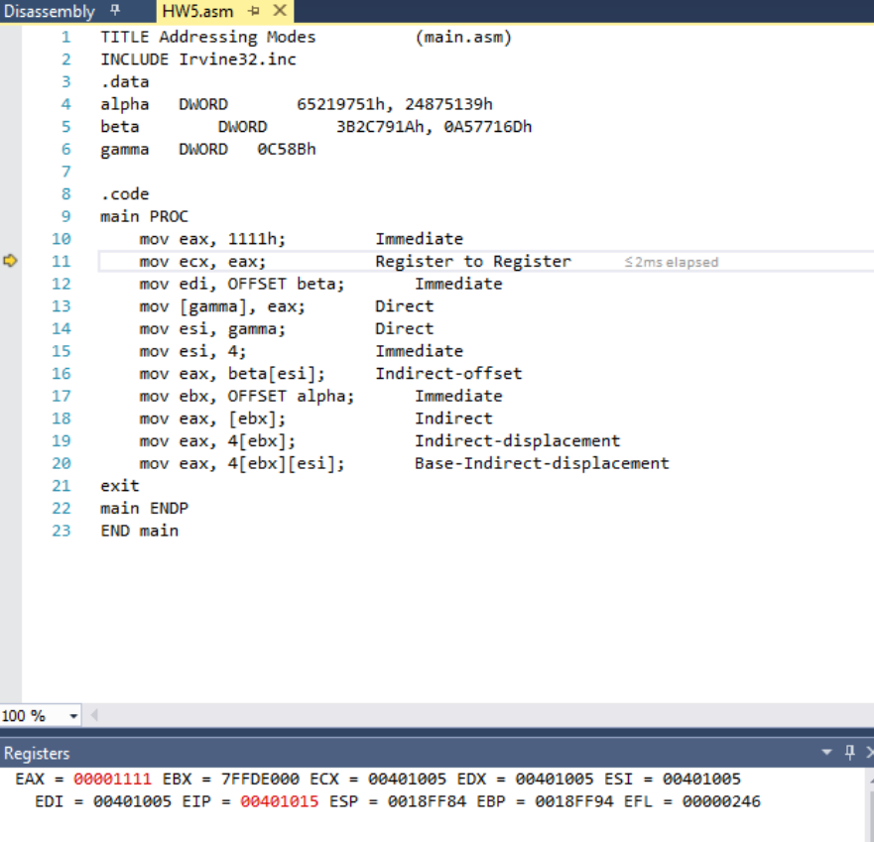
STEP 3:
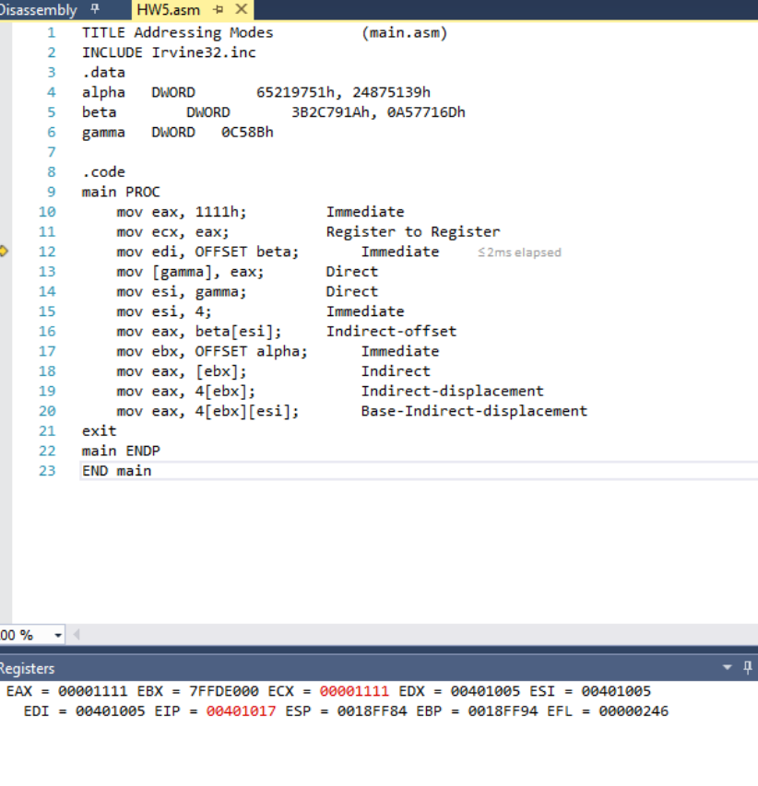
STEP 4:

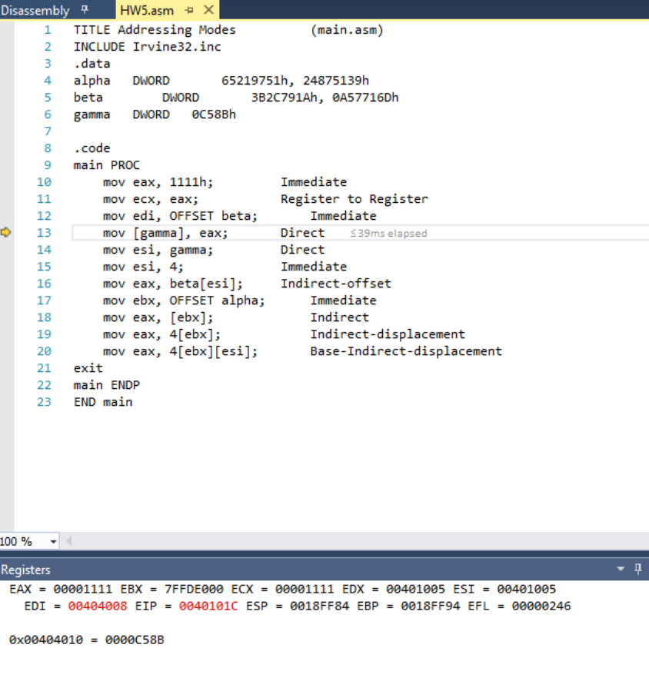
STEP 5:
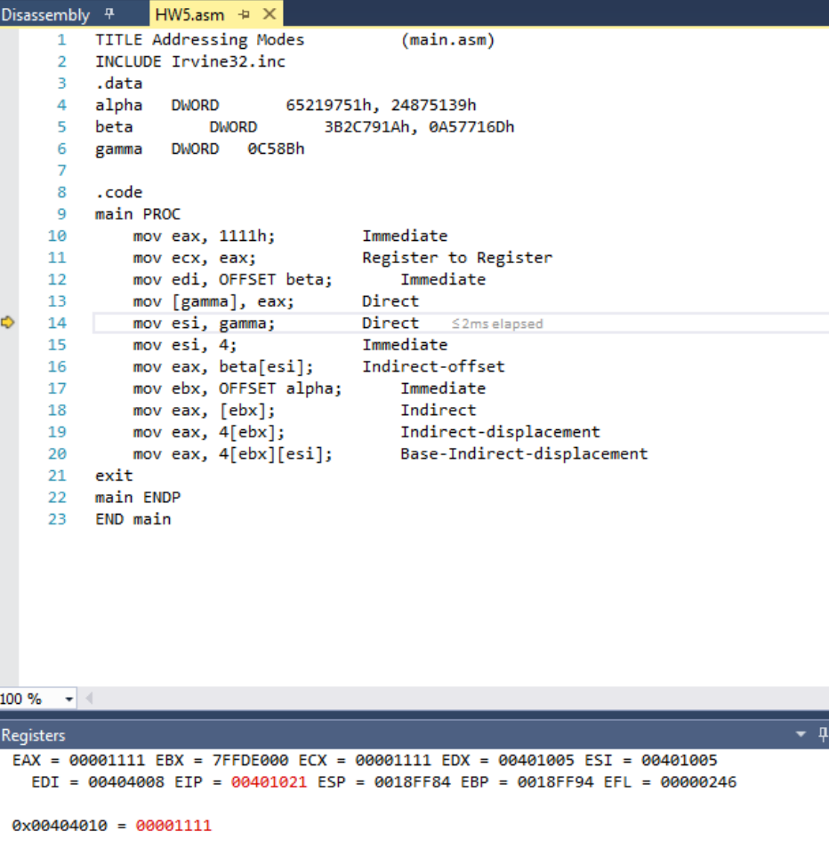
STEP 6:
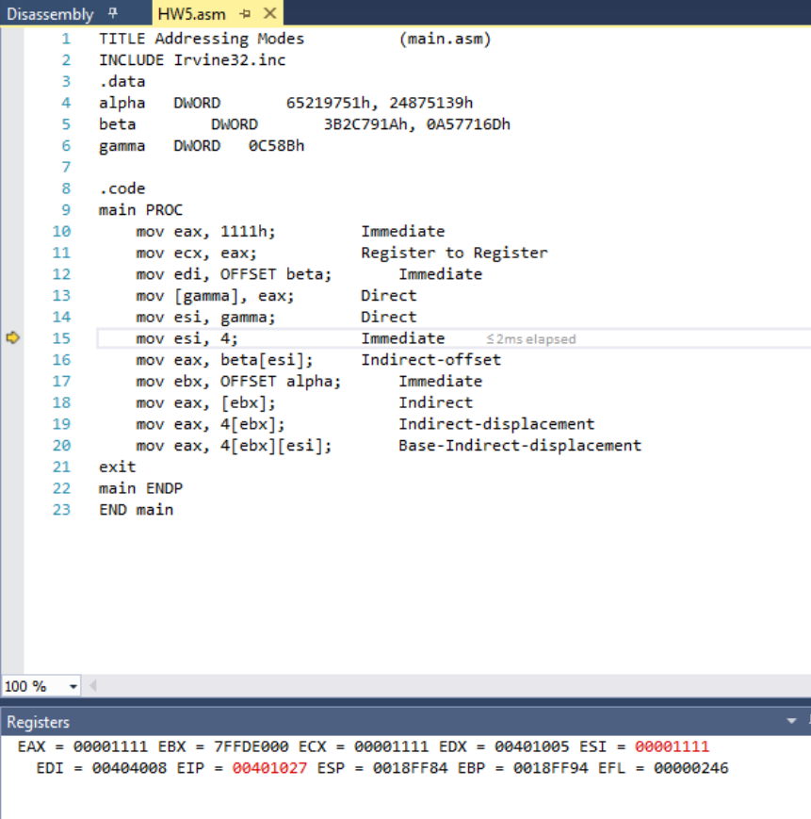
STEP 7:
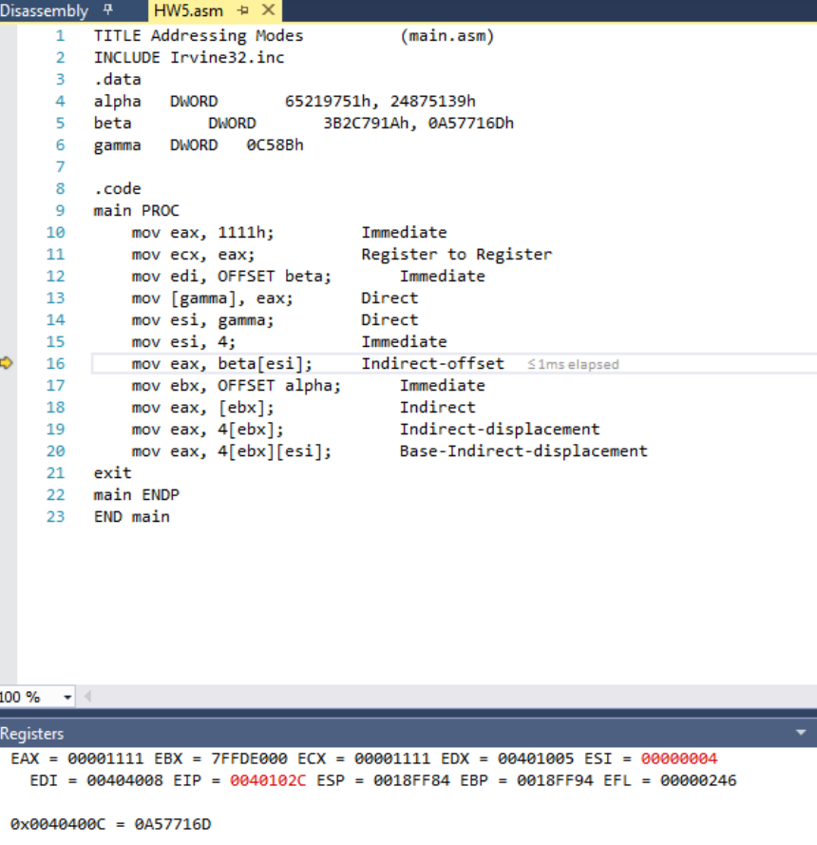

STEP 8:
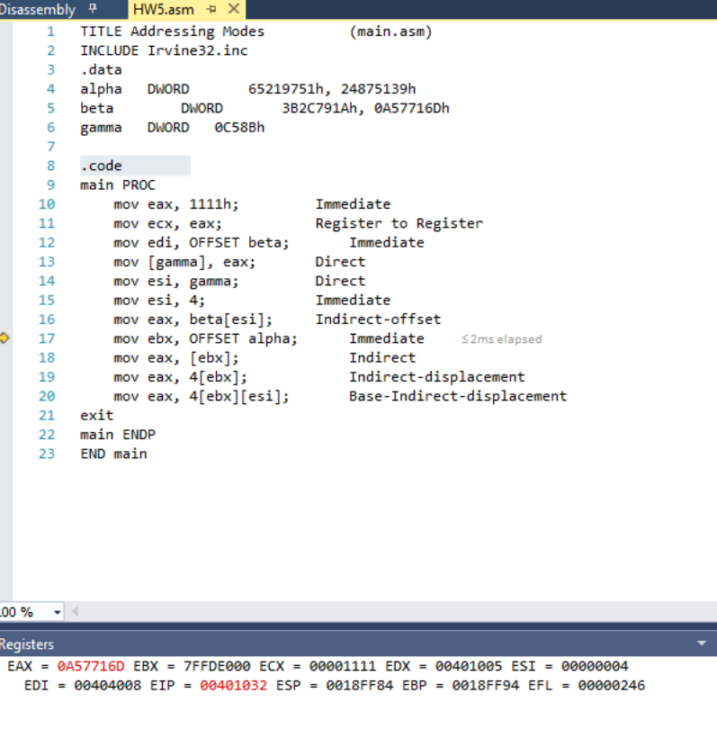
STEP 9:
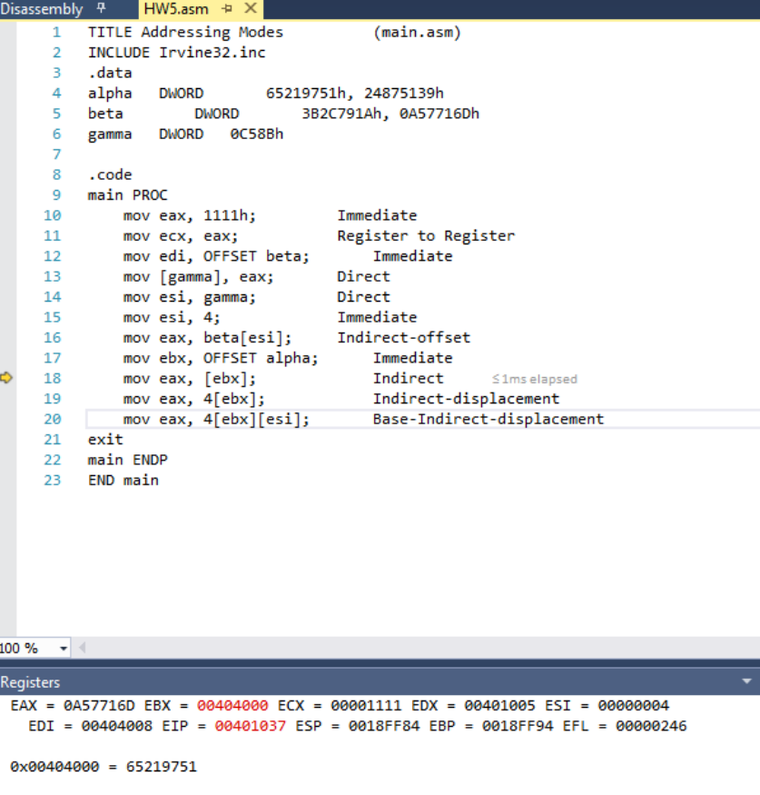
STEP 10:
STEP 11:
STEP 12:
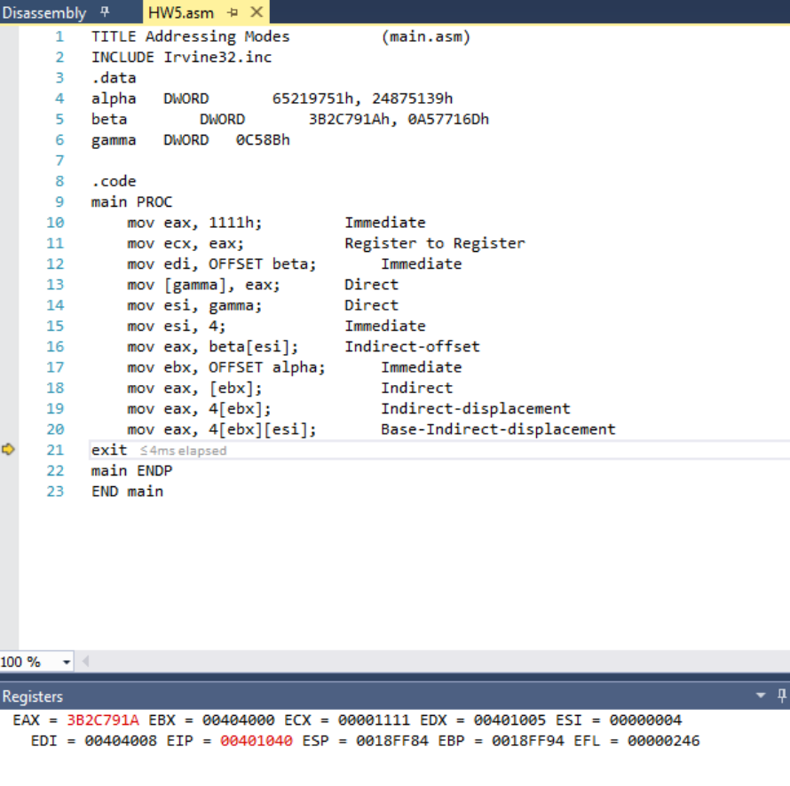

Linear Address Calculations:

mov eax, 1111h; Immediate
mov ecx, eax; Register to Register
mov edi, OFFSET beta; Immediate
mov [gamma], eax; Direct; 0x010B4010 = 0000C58B
mov esi, gamma; Direct; 0x010B4010 = 00001111
mov esi, 4; Immediate
mov eax, beta[esi]; Indirect-offset; 0x010B400C = 0A57716D
mov ebx, OFFSET alpha; Immediate
mov eax, [ebx]; Indirect; 0x010B4000 = 65219751
mov eax, 4[ebx]; Indirect-displacement; 0x010B4004 = 24875139
mov eax, 4[ebx][esi]; Base-Indirect-displacement; 0x010B4008 = 3B2C791A
invoke ExitProcess,0;
main ENDP
END main

- [Indirect addressing] Write a program that subtracts the corresponding even indexed elements of Array2 from Array1 and stores the results in Array3; e.g. for the 8th element, Array3 [7] Array1 [7] - Array2 [7]. Note that Array3 will have about half the number of elements of the other two arrays. Include commands to display the elements of all the arrays. Submit screenshot of the displays of the elements of all the arrays. You can use WriteInt or WriteHex to display the elements of the arrays. Fill in Array1 and Array2 each by your own ten numbers.

.data
Array1 WORD 7h, …
Array2 WORD 4h, …
Array3 WORD 10 DUP (?)

For example, if we have:

Array1 WORD 9h, 8h, 7h, 6h
Array2 WORD 1h, 2h, 3h, 4h

Then the expected result stored in Array3 should be:
8h,4h
OUTPUT:
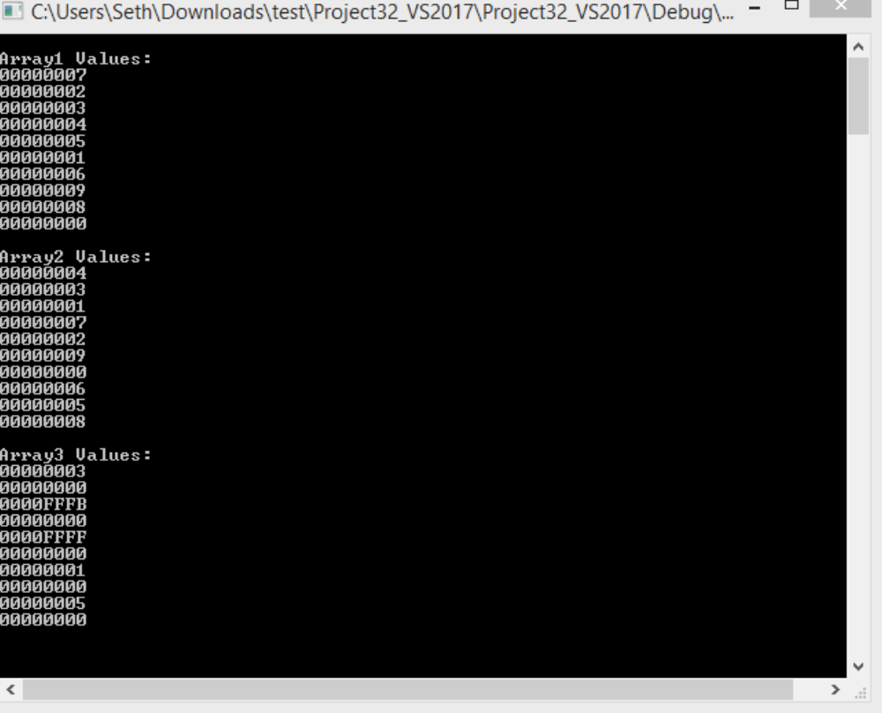
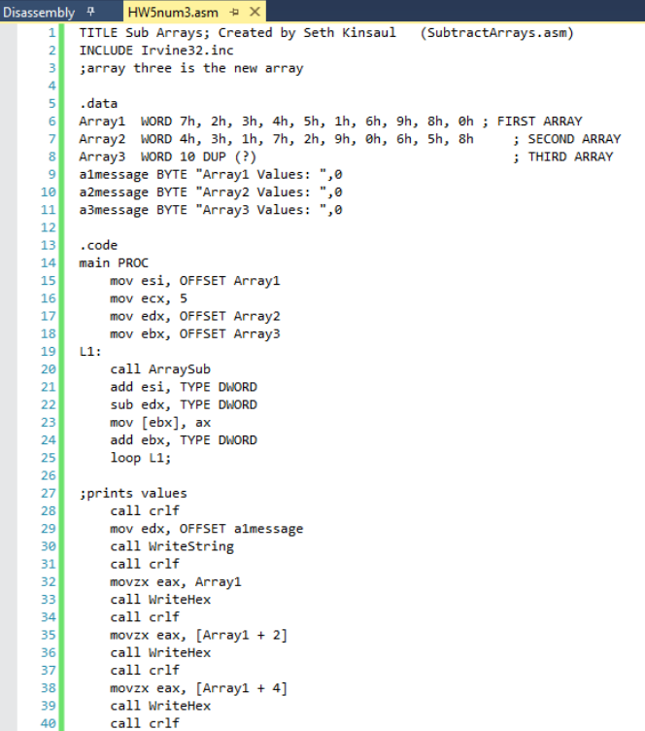
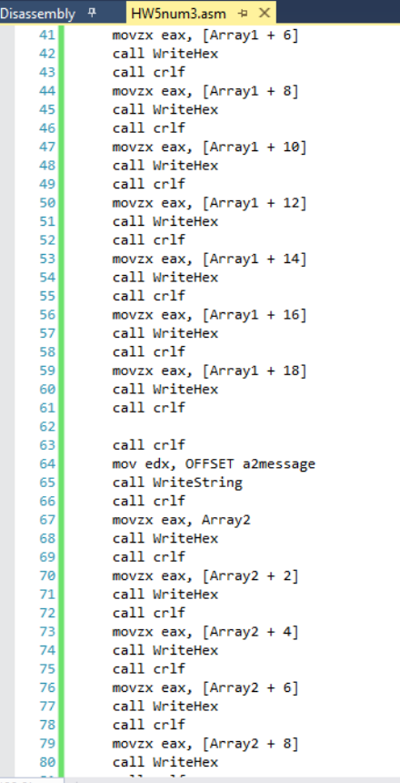
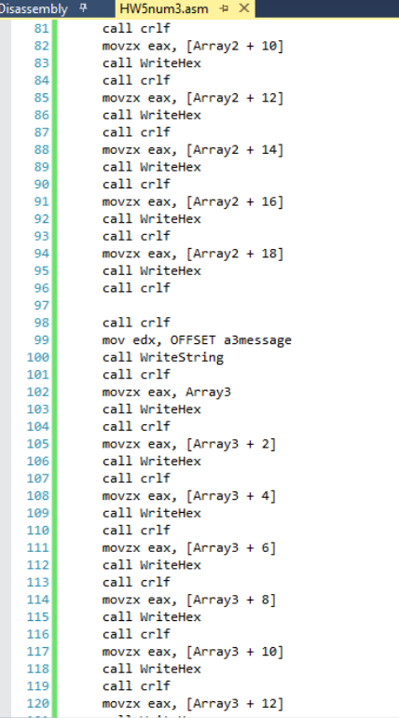
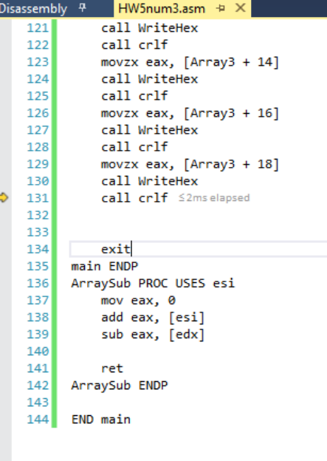

- [Loops] Write a program to compute the sum of first n integers of the series: Sum = 1 + 2 - 3 + 4 -5 + 6 -7 +8 - 9… Your program must:

  - Prompt user for integer n,
  - Read the value of n from user input
  - Calculate Sum, and;
  - Print Sum on screen.

Please use the “WriteInt” procedure, not “DumpRegs”. Other relevant procedures: “ReadInt” and “WriteString.” The calculation can be done in many ways, and all submissions that evidence proper programming practice are acceptable. In your homework submission, please embed both the code and one screen shot for n = 10.

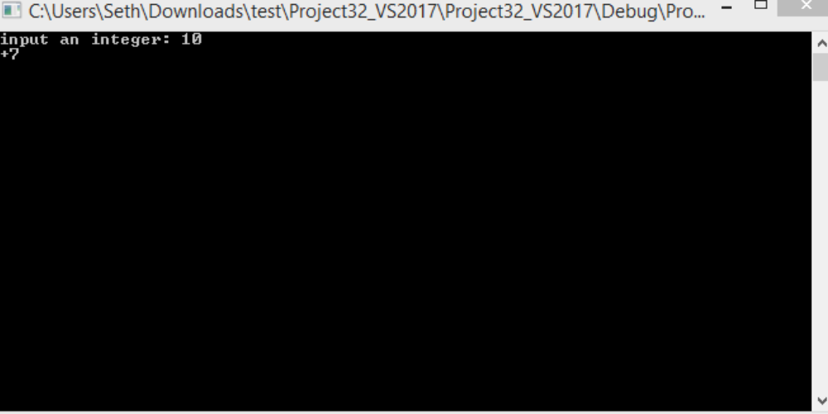
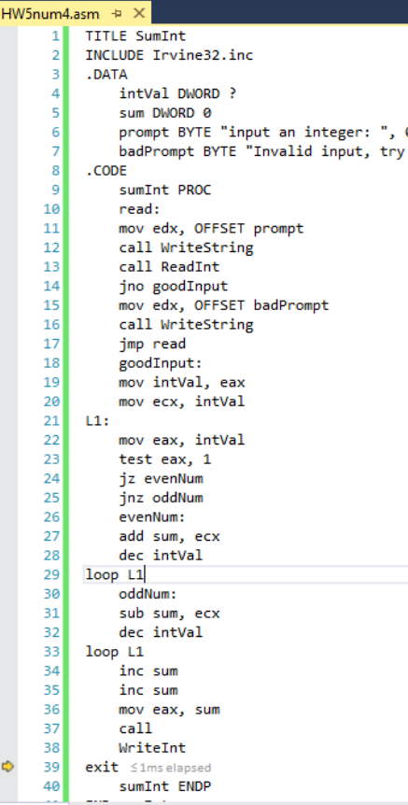
Line41: END sumInt

